**Steps for media planning**

This reading provides more information about the contents of a digital media plan and the general steps to create one.

**Digital media plan contents**

You learned in a video that a digital media plan contains details about where, when, and how often ads will appear across digital media channels, and includes the following information:

* Target audience
* Budget
* Media mix
* Duration
* Key performance indicators (KPIs)
* Performance goals and metrics

Here are descriptions of each, along with the purpose they serve in a digital media plan.

**Target audience**

A **target audience** is the group of people most likely to purchase the products or services being  advertised. Sometimes, a target audience is defined by a combination of customer personas that help marketers determine how to reach people using the right messages, offers, and products. A digital media plan should leverage customer personas as much as possible. A digital media plan can also include audience demographics, such as age, income, devices used, and preferred media for the content consumed. However, demographic  information might not be available from all customer personas.

**Purpose:** A target audience is documented in a digital media plan for purely economic and strategic reasons. You want to spend a limited campaign budget on the people most likely to make a purchase.

**Budget**

Campaigns usually have a fixed **budget** allocated from a larger marketing budget. Spending more than what is budgeted for a campaign often requires further justification and approval.

**Purpose:** A budget is documented in a media plan to help prevent over- or under-spending for a particular channel during a campaign.

**Media mix**

A **media mix** specifies how much of a budget will be spent across each media channel in a campaign. If actual amounts are unknown, you can specify percentages of the budget in the media mix. For example, you could assign $20,000, or 30% of the budget to social media. Either is acceptable in a media plan.

**Purpose:** A media mix is critical to a media plan because it enables the right content decisions to be made based on an allocated budget for any particular media channel.

**Duration (flight)**

**Duration**, also referred to as flight, is the length of a campaign and is easy to document. But if you’re running a campaign using a pay-per-click (PPC) model, duration becomes trickier because you’ll need to ensure your budget is sufficient for the entire duration of the campaign. For campaigns like these, duration is heavily influenced by budget.

**Purpose:** Duration, or flight, in a digital media plan specifies how long the campaign will run.

**Key performance indicators (KPIs)**

A **key performance indicator**, or KPI, is a measurement or metric used to gauge how successful a campaign is. It’s important to include KPIs for each media channel in a digital media plan so you can measure the success of a campaign at that level. For example, in another video lesson, you learned how each channel can have its own return on ad spend, or ROAS, as a measure of success.

**Purpose:** KPIs in a media plan document how you will measure campaign success for each media channel.

**Performance goals and metrics**

A **performance goal** is a target that has a measurable, numeric value. Performance goals help define success. If metrics meet or exceed a performance goal during a campaign, the campaign is successful. Clickthrough rate (CTR), the number of clicks divided by the number of impressions, is a popular metric for ads.

**Purpose:** Including performance goals in a media plan allows you to consistently measure the performance and success of each media channel during a campaign.

**Steps to create a digital media plan**

Assuming that business and marketing goals have already been created, here are the general steps to create a digital media plan:

1. **Confirm business goals**: Assuming that these have already been established, identify and confirm what they are.
2. **Confirm marketing goals:** Assuming that these have already been created, identify and confirm what they are.
3. **Conduct market research:** (Optional) If a target audience isn’t clearly identified, market research can help you determine what it is. For example, market research can determine both customer personas and target audience.
4. **Define performance (also called campaign) goals:** Be clear on what the campaign should achieve. Campaign goals usually have a relationship with a higher-level marketing or business goal. For example, if sales growth needs to occur in a particular region, a campaign’s goal can be to increase brand awareness through ads directed at users in that region.
5. **Select the media channels:** Media channels selected for a campaign should align with the media preferences of the target audience. A media mix can then be created after identifying which channels have the highest priority.
6. **Determine and document all media plan items:** After you have determined the required items for a digital media plan, you can use a document or software media planning tools to help you create the plan.

**Format of a digital media plan**

A digital media plan can be created in many formats. You can use documents, spreadsheets, or even specialized media planning tools. Remember that the format of a digital media plan isn’t as important as its contents.

**Digital media plan templates**

If you use a document for your digital media plan, media planning templates are widely available. You can also create your own organization format. Below is an example of a basic table that can assist with media planning. Sample content is in italicized text.

| **Marketing Goals** | **Budget** | **Duration** | **Target Audience** | **Media Channels** | **Media Mix** | **KPIs** | **Performance Goals and Metrics** |
| --- | --- | --- | --- | --- | --- | --- | --- |
| *Grow brand awareness of target audiences* | *$75,000* | *3 months* | *Adults 50-65 years old* | *Display* | *60%* | *CTR* | *5% increase in page views*  *CTR > 2%* |
|  |  |  | *All adults* | *Search* | *30%* | *CTR* | *10% increase in page views*  *CTR > 2%* |
|  |  |  | *Adults 18-49 years old* | *Social Media* | *10%* | *Audience growth rate* | *20% or greater audience growth rate* |

In a digital media plan, you can also include a reference image of a marketing funnel to map performance goals and metrics to the relevant stages of the funnel. This helps people visualize what your campaign is trying to achieve at any given stage. The illustration below is an example.

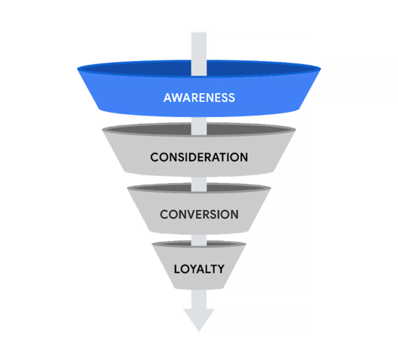

| **Target Audience** | **Media Channels** | **Media Mix** | **KPIs** | **Performance Goals and Metrics for AWARENESS** |
| --- | --- | --- | --- | --- |
| Adults 50-65 years old | Display | 60% | CTR | 5% increase in page views  CTR > 2% |
| All adults | Search | 30% | CTR | 10% increase in page views  CTR > 2% |
| Adults 18-49 years old | Social Media | 10% | Audience growth rate | 20% or greater audience growth rate |

**Media planning tools**

If you use media planning software to create a media plan, there are many tools to choose from. A HubSpot blog article identifies twelve available media planning tools in their *Essential Media Planning Tools* list.

[15 Essential Media Planning Tools:](https://blog.hubspot.com/marketing/media-planning-tools) Provides website links for several media planning tools

**Key takeaways**

A digital media plan contains details about where, when, and how often an ad will appear across digital media channels. Documenting KPIs and metrics for each channel is essential for measuring campaign success. Media planning can be achieved using documents or specialized media planning tools. The organizational format of a media plan can vary, and many templates are available.